TUGAS SRUKTUR DATA
IMPL EMENTASI QUEUE MENGGUNAKAN ARRAY

Nama :Moh Rama Alan Wijaya
NIM :250631100093
Kelas :2D

TUGAS: Ganti elemen queue dengan 3 digit akhir NIM sendiri.Cantumkan sreenshot code dan hasil dari netbeans

- Source code

public class QueueArray {
private int capacity;
int queueArr[];
int front = 0;
int rear = -1;
int currentSize = 0;
public QueueArray(int queueSize) {
this.capacity = queueSize;
queueArr = new int[this.capacity];
}
// Menambahkan data ke antrean
public void enqueue(int item) {
if (isQueueFull()) {
System.out.println("Overflow (Penuh)! Tidak dapat menambahkan data: " + item);
} else {
rear++;
queueArr[rear] = item;
currentSize++;
System.out.println("Data " + item + " memasuki antrean -> rear : " + rear);

if (rear == capacity - 1) {
rear = -1;
}
}
}
// Menghapus data dari antrean
public void dequeue() {
if (isQueueEmpty()) {
System.out.println("Underflow (Kosong)! Tidak dapat menghapus data!");
} else {
int data = queueArr[front];
queueArr[front] = 0;
front++;
currentSize--;
if (front == capacity) {
System.out.println(data + " terhapus -> front kembali ke 0");
front = 0;
} else {
System.out.println(data + " terhapus -> front : " + front);
}
}
}
// Mengecek antrean penuh
public boolean isQueueFull() {
return (currentSize == capacity);
}
// Mengecek antrean kosong
public boolean isQueueEmpty() {
return (currentSize == 0);
}

public static void main(String[] args) {

QueueArray queue = new QueueArray(3);

// 3 digit akhir NIM = 093
queue.enqueue(93);
queue.enqueue(93);
queue.enqueue(93);

queue.dequeue();
queue.dequeue();
queue.dequeue();
queue.dequeue(); // untuk menampilkan Underflow
}
}

- Sreenshot code

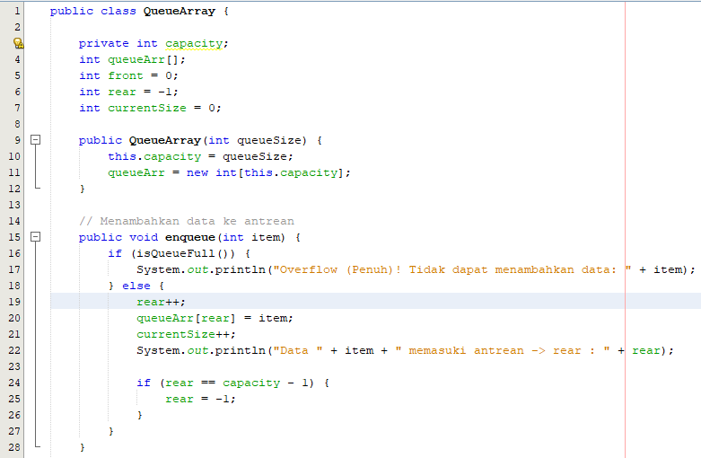

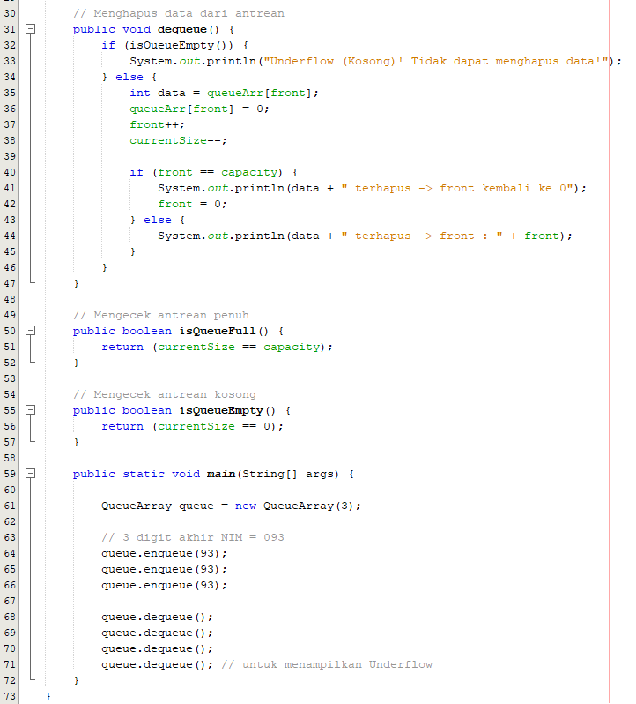

- Sreenshot Output
